Accelerate task on creating workflow handlers through BMIDE

1. Create a library in BMIDE and make it as Active Library

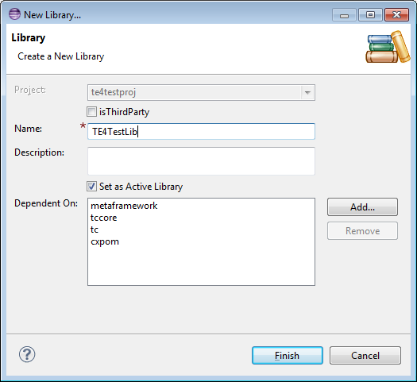

1. Create an extension in BMIDE

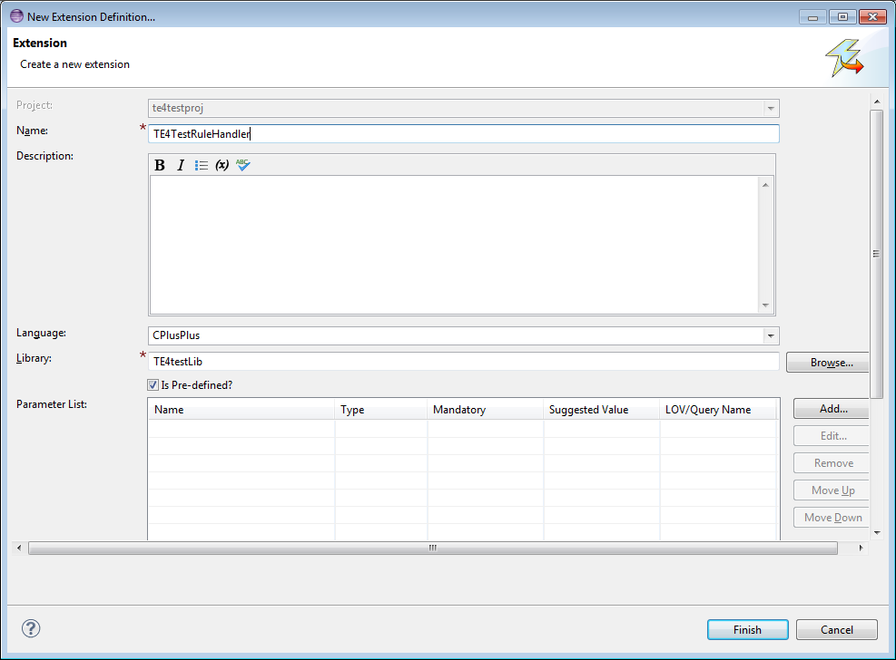

1. In the Availability field; click add and enter the following information

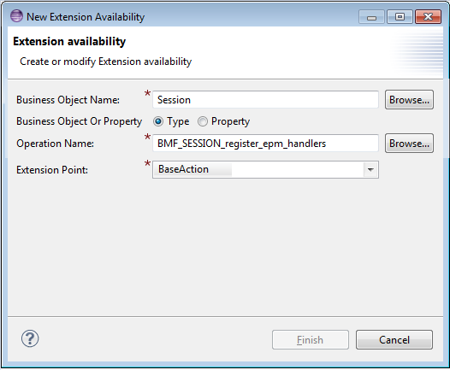

1. Search for Session Business Object and click on Operations tab

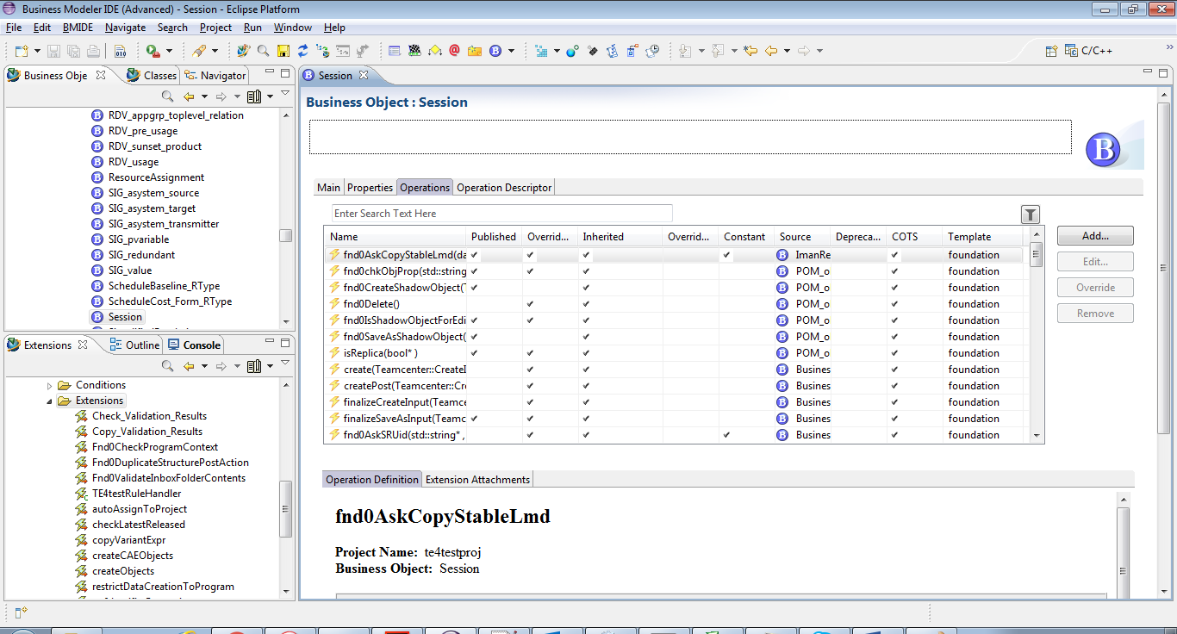

1. Search for **BMF_SESSION_register_epm_handlers** and Click the Extension Attachments tab, and add the extension created above

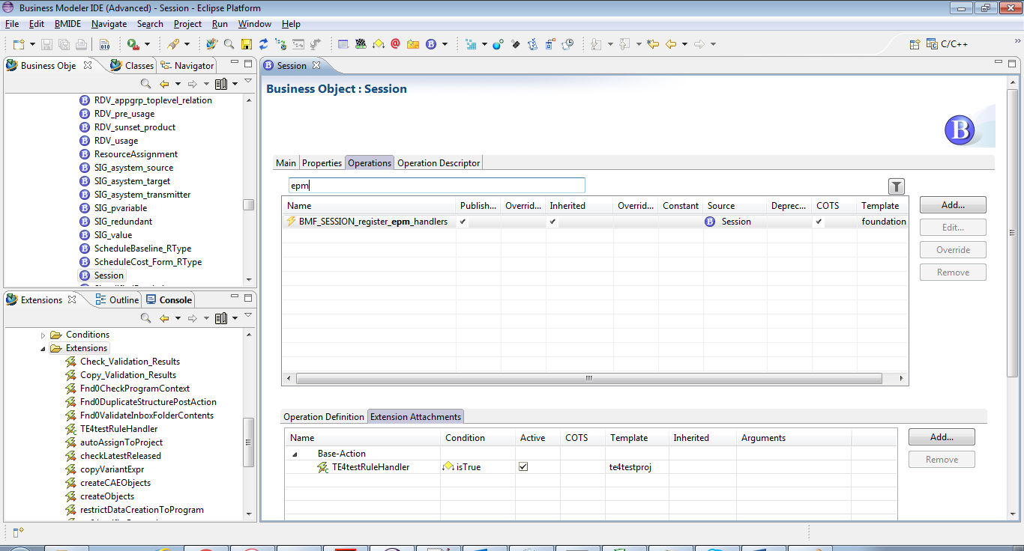

1. Right Click the Extension folder and select Generate Extension code

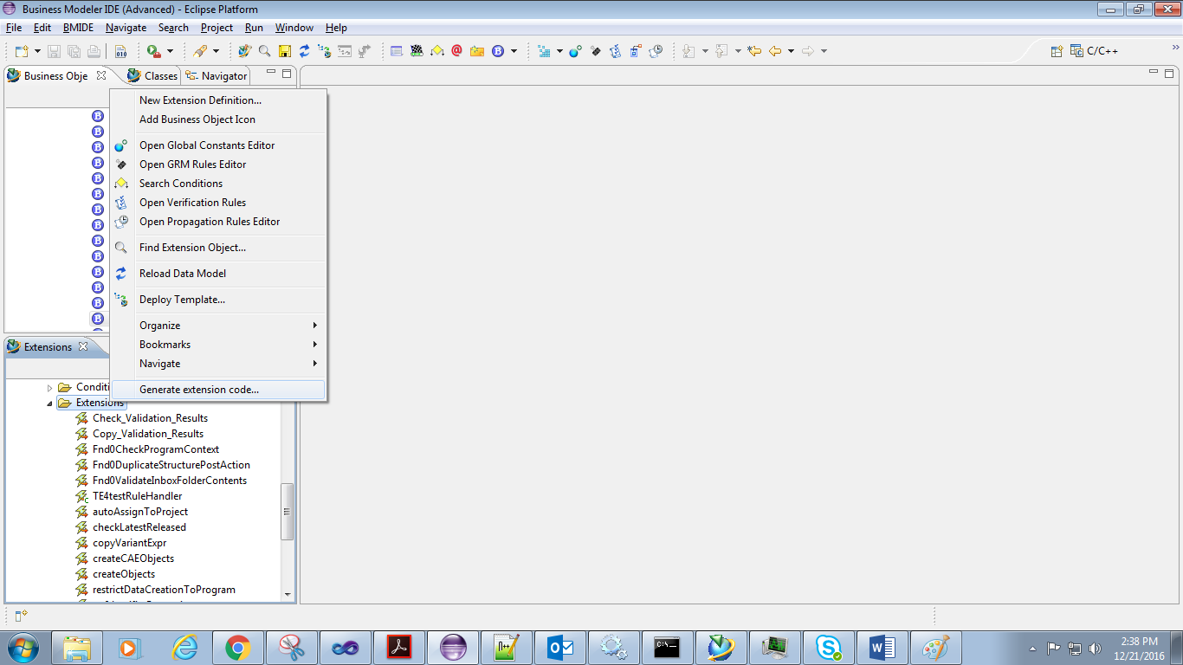

1. A new folder named “src” would be created in the Navigator tab. Need to refresh the project if src folder is not displayed. This folder will have .cxx and .hxx files

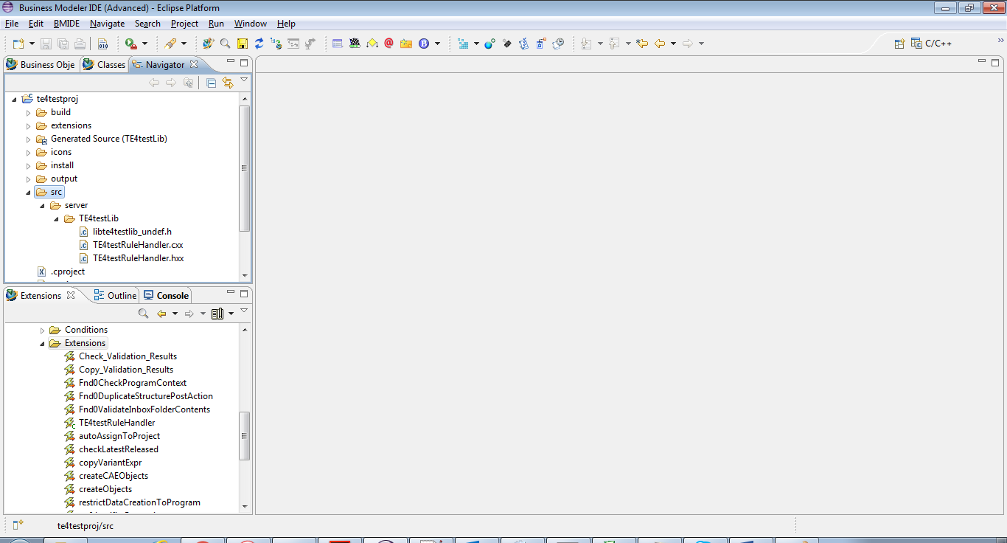

1. Open the Standard perspective and Right Click the Business Object folder and select Generate Code🡪 C++ Classes

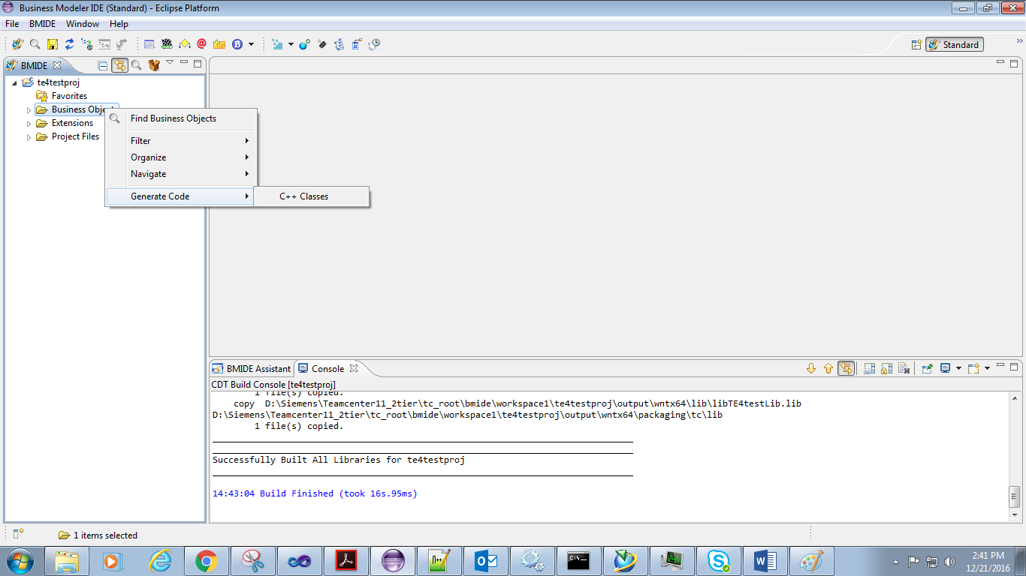

1. Change the perspective to C/C++ and write the code in .cxx and .hxx files

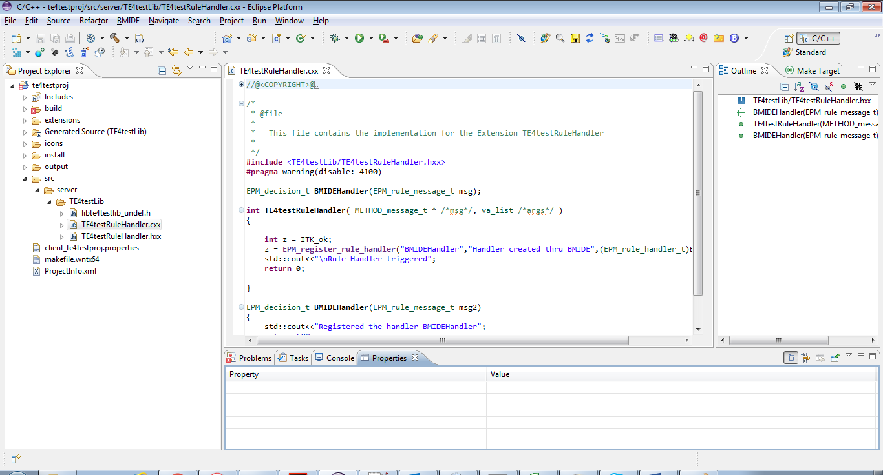

1. Right Click the project folder and select Properties and give the path of TC_ROOT in Teamcenter Installation field and Visual Studio’s VC/bin folder path in Compiler Home field

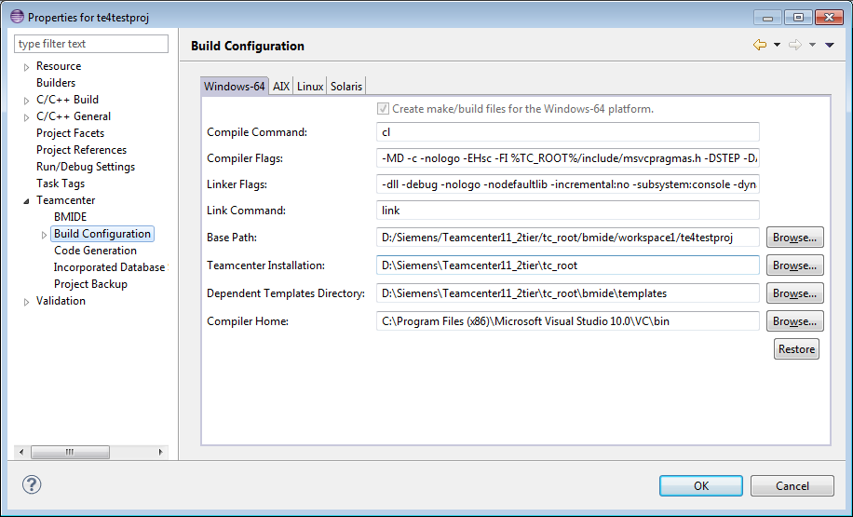

1. Edit the BMIDE.bat file and add the following:

* set JAVA_HOME=C:\Program Files\Java\jdk1.7.0_55
* set JDK_HOME=C:\Program Files\Java\jdk1.7.0_55
* set MSDEV_HOME="C:\PROGRA~2\Microsoft Visual Studio 10.0\VC"
* CALL %MSDEV_HOME%\vcvarsall.bat x86_amd64
* set PATH=%JRE_HOME%\bin;%JDK_HOME%\bin;%TC_ROOT%\lib;%FMS_HOME%\bin;%FMS_HOME%\lib;%FMS_HOME%;%PATH%;%MSDEV_HOME%\lib;%MSDEV_HOME%\bin;%MSDEV_HOME%\include

1. Open the makefile and add the path of your BMIDE project

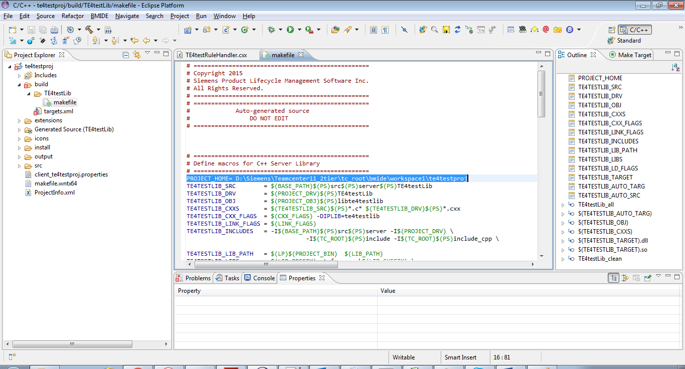

1. Also add the highlighted text in makefile, this will help BMIDE recognize epm related ITK calls

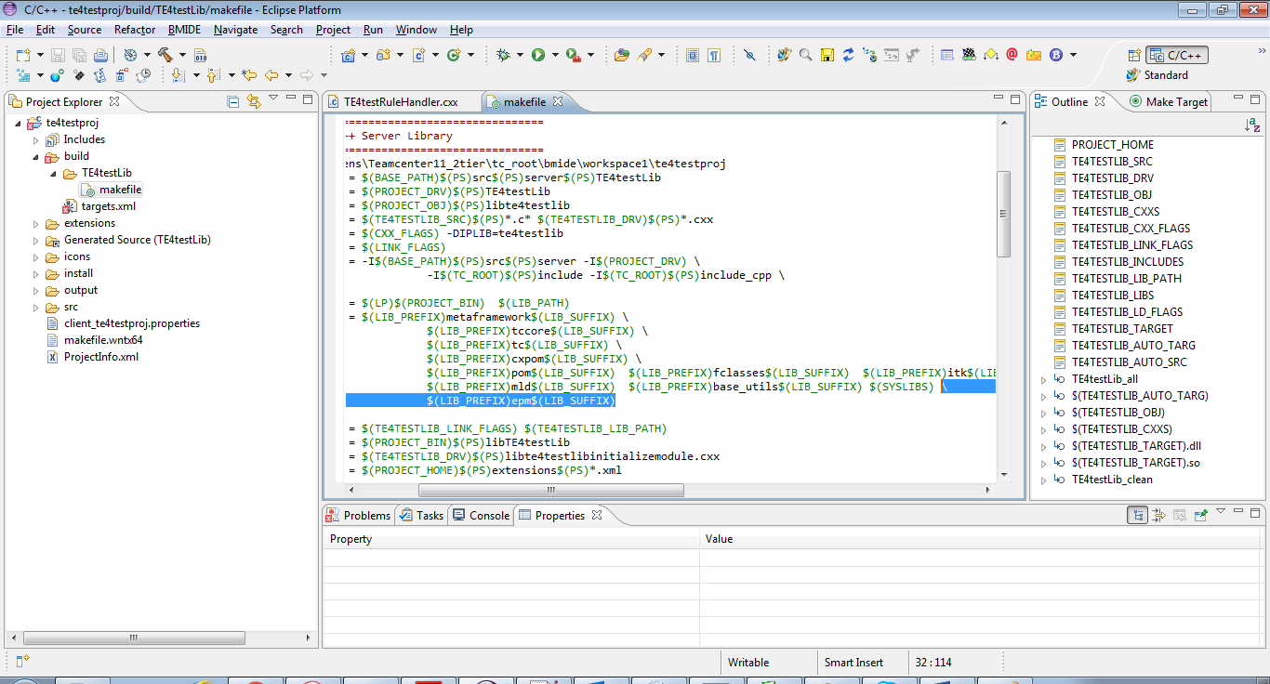

1. Build the code by selecting Project🡪Build Project
2. After a successful build, dll, lib and pdb files would be created under **output\wntx64\lib** folder

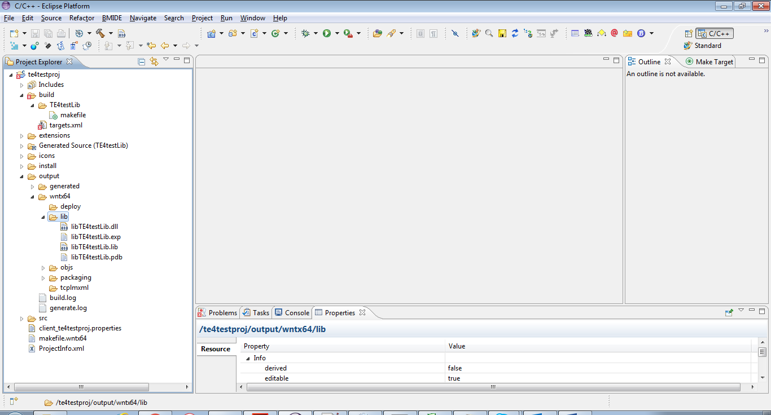

1. Copy dll and pdb file in TC_ROOT\bin and lib file in TC_ROOT\lib folder
2. Deploy the BMIDE package
3. In Teamcenter update the TC_customization_libraries by adding the library name of the project created above

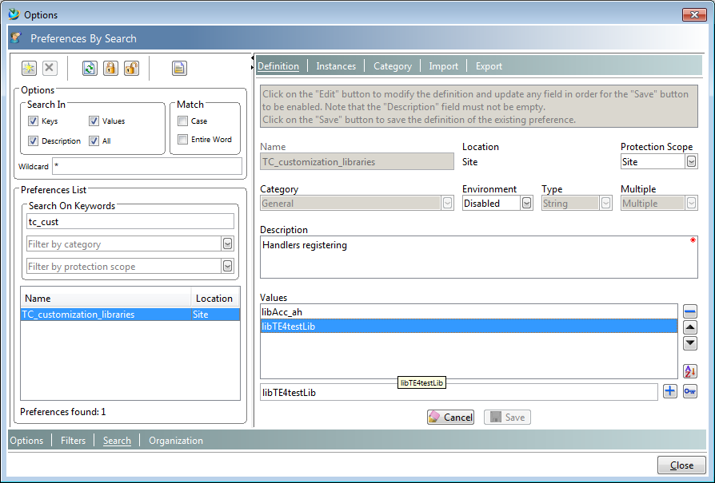

1. Go to Workflow Designer and create a new template, the new handler would be visible

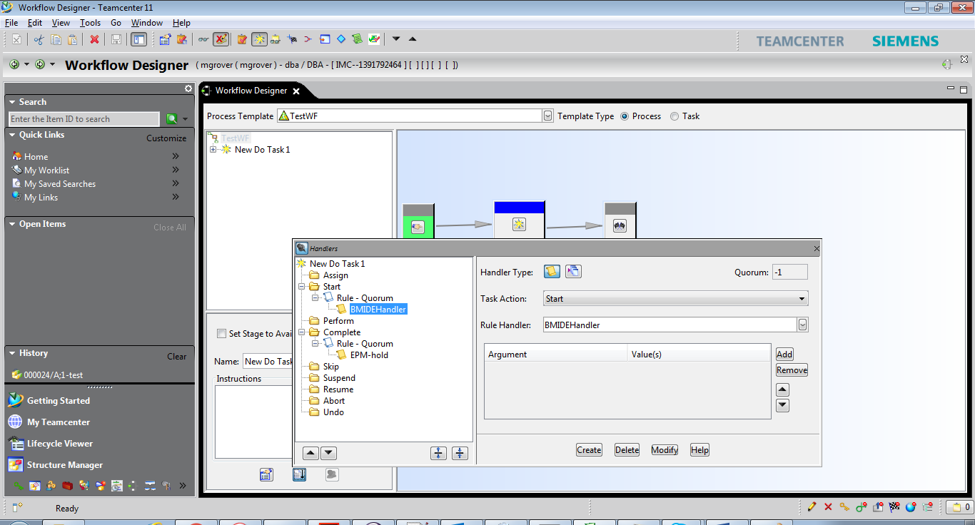

1. Set the stage of Workflow template Available and initiate the workflow on any item revision

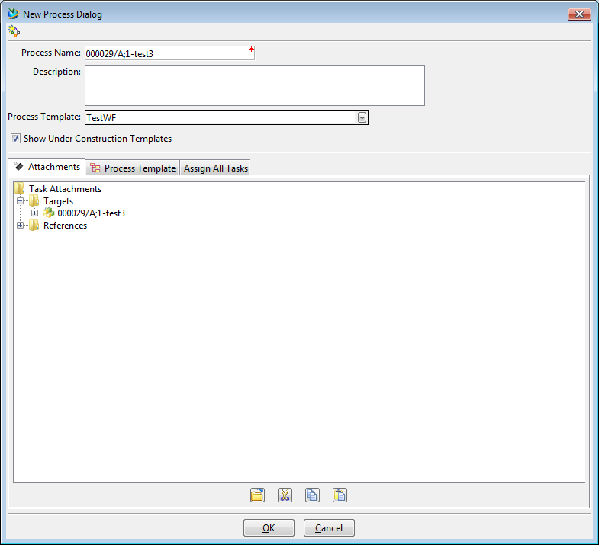

1. Since only printf statement was added in the handler’s code, so this statement is getting printed whenever the handler is called

